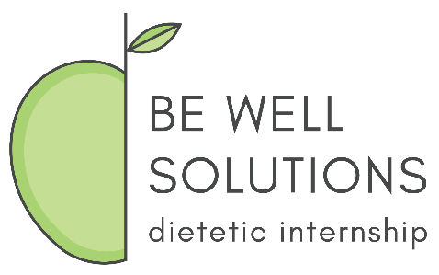
Be Well Solutions Dietetic Internship
Prior Assessed Learning (PAL) Portfolio Instructions

The PAL Portfolio is one of the requirements of the BWS DI PAL Application. The purpose of the portfolio is to provide documentation to support the experiences outlined in the applicant’s Rotation Competency Form(s). A separate portfolio must accompany each Rotation Competency Form submitted.
PAL Portfolio Requirements:
- Table of Contents
- Documents – Examples may include but are not limited to:
  - Primary – training certificates, performance evaluations/appraisals, licenses
  - Secondary - seminars/presentations, marketing content, menus, webinars, reports, patient/client educational materials, lesson plans, budget reports
- Content Descriptions – for each document included in the portfolio, describe the intent of the content and reference the learning competency(s) (CRDNs) in which you feel you gained proficiency by completing the work. This should match what you have listed in the Rotation Competency Form.
Please be sure to keep copies of all documents included in the portfolio as they will not be returned to the applicant. PAL Portfolio(s) are to be submitted at the same time as the other requirements for the BWS DI PAL Application.
The PAL Portfolio is due two weeks after acceptance in the BWS DI program.

