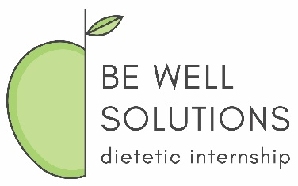
Be Well Solutions Dietetic Internship Program
Wellness Supervised Practice Experience
PAL - Rotation Competency Form

Employee’s Name: | Facility Name:
Supervisor’s Name: | Dates of experience:

Instructions: Listed below are the ACEND-required learning competencies (CRDN) assigned to the BWS DI Wellness Supervised Practice Experience. After reviewing each competency, please choose the CRDN(s) you feel you have fulfilled based on your prior experience and provide further explanation of that experience, being as detailed as possible. For each experience, describe the skills and level of expertise that you obtained (ex. “As a certified health coach, I provided 45-minute nutrition counseling sessions to approximately 15-25 clients per week, helping me to master the skill of motivational interviewing”). If there is documentation to support the experience, please include it in the PAL Portfolio and reference it here in bold in the “Skills Mastered” column for that corresponding CRDN. For further examples of documentation, please refer to the PAL Portfolio instructions. A given experience can be applied toward the fulfillment of more than one CRDN.

Competencies | Description of Learning Experience/Responsibilities | Skills Mastered
Scientific and Evidence Base of Practice: Integration of scientific information and translation of research into practice.
CRDN 1.4 Conduct projects using appropriate research or quality improvement methods, ethical procedures and data analysis utilizing current and/or new technologies.
Clinical and Client Services: Development and delivery of information, products and services to individuals, groups and populations.
CRDN 3.7 Demonstrate effective communication and documentation skills for clinical and client services in a variety of formats and settings, which include telehealth and other information technologies and digital media.
CRDN 3.8 Design, implement and evaluate presentations to a target audience.

CRDN 3.9 Develop nutrition education materials that are culturally and age appropriate and designed for the literacy level of the audience.
CRDN 3.10 Use effective education and counseling skills to facilitate behavior change.

CRDN 3.11 Develop and deliver products, programs or services that promote consumer health, wellness and lifestyle management.
CRDN 3.12 Deliver respectful, science-based answers to client/patient questions concerning emerging trends.

Practice Management and Use of Resources: Strategic application of principles of management and systems in the provision of services to individuals and organizations.
CRDN 4.7 Conduct feasibility studies for products, programs or services with consideration of costs and benefits.
Corporate Wellness BWS DI CRDNs
CRDN 6.5 Develop educational handout related to a specific nutrition topic.

CRDN 6.7 Develop and present health related seminar to employees in worksite setting.

CRDN 6.8 Contribute to development of wellness newsletter, poster or other written communication tool.

Total hours of experience at the facility: ____________________

Employee Signature: _______________________________________ Date: _________________________________

Attestation
By signing this, I attest that the experiences/responsibilities and/or knowledge outlined above were achieved during the employee’s position at our facility and I confidently believe they are competent in each of the learning competencies chosen above.

Supervisor’s Signature: ____________________________________ Date: _________________________________

