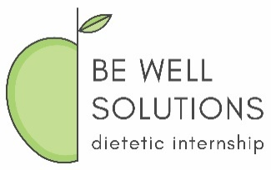
Be Well Solutions Dietetic Internship Information Release Authorization
In accordance with the Family Educational Rights and Privacy Act of 1974, Be Well Solutions Dietetic Internship Program (BWSDI) will only disclose confidential information obtained from applicants/interns to third parties provided the Internship has written consent from the applicant/intern on file.
To facilitate ease of application, the prospective candidate may choose to share information provided through the DICAS application and other avenues with potential graduate programs. Additionally, the applicant information may be sent from the graduate program to BWSDI. Following acceptance into the graduate program, information exchange would continue to facilitate the candidate’s progress.
The applicant hereby acknowledges and approves the release of information, including but not limited to, grades/GPA, demographic, enrollment, past and present academic status, for sharing by and between the graduate program, ___________________________ , and BWSDI.
This authorization shall continue until revoked, in writing, by the applicant.
Applicant Information
Name (Last, First, Middle Initial) | DICAS ID Number
Current mailing address | Phone number  ( )
 | Applicant email address

_________________________ _________________
Signature of Applicant Date of Signature

