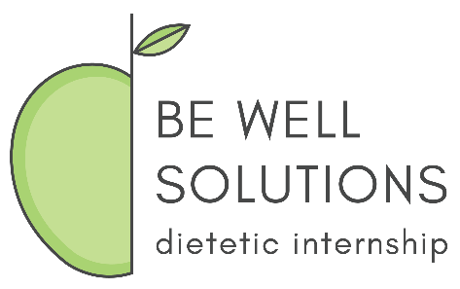
Be Well Solutions Dietetic Internship
Second Round Match – Intent to Apply Form

Thank you for your interest in the BWS DI program. If you haven’t done so already, we highly encourage you to review the BWS DI Second Round Match Instructions before submitting this form. The instructions can be found on the BWS DI Website.
Please complete the form below to the best of your ability and email it to bwsdi@bewellsolutions.com.
Deadline: Candidates may submit the form any time after the release of First Round Match results on Sunday, April 7. BWS DI will begin contacting potential second round applicants for interviews on a rolling basis, so it would be to your advantage to submit this form early in the second round process. In addition to scheduling interviews, the program will request that promising candidates formally apply to BWS DI via DICAS. BWS DI will extend formal offers starting on Wednesday, April 10 at 11:00 am CT.
Questions? Contact bwsdi@bewellsolutions.com or visit the Second Round Match section of our website.

- Name: __________________________________

- Address: __________________________________

- Will you be completing your rotations near the above address? Yes No
If not, please tell us in which town(s) you plan to complete your rotations: ________________________________________

- Contact Information:
  - Phone Number: _________________________ cell other: _________
  - Email: _________________________________

- Undergraduate School: __________________________

- Undergraduate Degree: __________________________

- Undergraduate Graduation Date: __________________

- DPD Total GPA: _________________________________

- Master’s Degree:

  - No
  - Yes
    - School:
    - Degree/ Graduation Date:
    - GPA:

- BWS DI Pathway you are applying for:
  - DI-only
  - MS/DI Pathway:
___ University of Alabama
___ Arizona State University
___ Benedictine University
___ Cedar Crest College (CCC requires applicants to specify their intended track):
___ Penn State University
___ Simmons College
___ West Chester University
- BWS DI Track you are applying for:
  - Full-Time
  - Part-Time

- If you have any nutrition-related work experience, please list the job title, employer and number of months/years you have worked in that position:
Job Title: ___________________________________________________________________
Employer: __________________________________________________________________
# of months/years in that position: ______________________________________________

Job Title: ___________________________________________________________________
Employer: __________________________________________________________________
# of months/years in that position: ______________________________________________

Job Title: ___________________________________________________________________
Employer: __________________________________________________________________
# of months/years in that position: ______________________________________________

- If you have other significant work experience, please list the job title, employer and number of months/years you have worked in that position:
Job Title: ___________________________________________________________________
Employer: __________________________________________________________________
# of months/years in that position: ______________________________________________

Job Title: ___________________________________________________________________
Employer: __________________________________________________________________
# of months/years in that position: ______________________________________________

Job Title: ___________________________________________________________________
Employer: __________________________________________________________________
# of months/years in that position: ______________________________________________

Thank you for submitting your form.
We look forward to reviewing your information!

